IT 166 Lab 12 pandas

Objectives

* Be able to use pandas to solve problems in Python.

Preparation

* Launch the Jupyter notebook.
* Rename the notebook page as “lab12”.
* Solution to one problem should occupy one cell.

Please provide solutions to the problems below.

Problem 1

|  |  |  |  |  |
| --- | --- | --- | --- | --- |
| ID | Name | Age | Midterm_1 | Midterm_2 |
| 1 | Alice | 19 | 100 | 80 |
| 2 | Bob | 21 | 85 | 99 |
| 3 | Caro | 20 | 90 | 85 |
| 4 | David | 22 | 77 | 75 |

Given the above table:

1. Create a DataFrame, with ID as the index. The columns should be in the exact order as they are in the table.
2. Compute the average of both midterm scores, and save them into a new column, named

“Average”.

1. Add one more column, named “Major”, set Alice and David’s major to IT; set Caro’s major to Mathematics; set Bob’s major to NaN.
2. Replace the index with the names. (You will need to get rid of the Name column after it has been used as index.)

Expect outcomes:

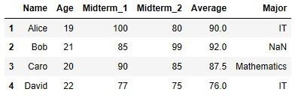

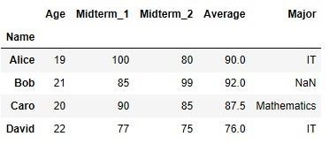

Problem 2

Use NumPy’s random number generator (randn) and pandas to create a DataFrame that has a shape of 5 by 5. Use only pandas or NumPy functions to solve the following problems:

1. Compute the sum of all the positive numbers and the sum of all the negative numbers.
2. Select all rows having a value exceeding 1.8 or -1.8 3) Drop a row and drop a column.

Expect outcomes:

